 |  | A/HRC/47/G/23
 | Advance Edited Version |  | Distr.: General  16 August 2021  Original: English
Human Rights Council
Forty-seventh session
21 June–9 July 2021
Agenda item 3
Promotion and protection of all human rights,
civil, political, economic, social and cultural rights,
including the right to development
Note verbale dated 5 August 2021 from the Permanent Mission of Greece to the United Nations Office at Geneva addressed to the Office of the United Nations High Commissioner for Human Rights
The Permanent Mission of Greece to the United Nations Office and other international organizations in Geneva provides herewith the comments of the Government of Greece in relation to the written statement submitted by six non-governmental organizations in special consultative status (A/HRC/47/NGO/201) (see annex).
The Permanent Mission of Greece kindly requests the Office of the United Nations High Commissioner for Human Rights to circulate the present note verbale and the annex thereto* as a document of the Human Rights Council, under agenda item 3.
Annex to the note verbale dated 5 August 2021 from the Permanent Mission of Greece to the United Nations Office at Geneva addressed to the Office of the United Nations High Commissioner for Human Rights
The statement submitted by the 6 NGOs on 31 May 2021 to the Human Rights Council contains a lot of inaccurate data and not updated information about the reception system and the rights of asylum seekers in Greece.
Since it largely refers to the conditions in the so-called hotspots, it needs to be reminded that it is about First Reception Facilities (RIC) that have been established on the islands of Lesvos, Chios, Samos, Leros and Kos. These facilities followed the hotspot approach as established by the European Commission during the 2015 crisis, in order to address specific challenges faced by member states at the external borders particularly exposed to migratory flows. They aimed to improve coordination of the EU agencies' and national authorities' efforts in the initial reception, identification, registration and fingerprinting of asylum-seekers and migrants. They were designed in order to offer proper reception conditions to asylum seekers and to ensure a fast and high-quality asylum process.
RICs were founded during the past decade and operated under uncertain and difficult circumstances when the Greek authorities had to deal for years with increased mixed migratory flows putting pressure to the social services on the islands. All RICs are about to be substituted by the new MPRICs (Multi-purpose Reception and Identification Centres). MPRICs are based on a modern layout which will cover all the needs of TCNs arriving in Greece (e.g., Primary Health Care Centres, safe areas for vulnerable persons such as UAMs and single-parent families etc. have been included in this layout). The first MPRIC to operate will be the one of Samos, in autumn 2021 (see Annex)
Contrary to the depressing picture described in the common statement of the six NGOs, the current situation on the Greek islands is completely different. The RICs are not overcrowded. On the contrary, the number of persons in RICs decreases. On July 19, 2021, 4366TCNs were hosted on Lesvos (RIC capacity8000), 330 on Chios (RIC capacity 1014),929 on Samos (RIC capacity 648)109 on Leros (RIC capacity 860) and 52 on Kos (RIC capacity 816). In total, 5786 TCNs were hosted on island RICs, while the capacity was11338 places. The majority of vulnerable TCNs have been transferred to reception facilities in the mainland of Greece and to apartments of the ESTIA/UNHCR accommodation programme. Thus, the stay of asylum seekers on the islands rarely exceeds the maximum of six months and even in these cases the prolongation of stay is justified (e.g., due to procedures to be followed because of the COVID 19 pandemic etc.).
Regarding in particular the RIC in Lesvos, it should be pointed out that there is no risk of flood, as the construction works concerning anti-flooding measures have been completed. At the same time, the construction of internal and external sewage net system is coming to an end. Partitioned rub-halls, containers and RHU have been deployed in the camp. All these types of accommodation are fully winterized and heated. In the camp there are 48 taps (one per 90 people and not one per 500 as inaccurately mentioned in the common statement). The number of toilets is sufficient (one per 11 people and not one per 100 as inaccurately mentioned in the joint statement). As for the showers, the ratio is 27 persons per shower. All the above-mentioned indicators are adequate according to the EASO and the SPHERE standards for the reception facilities (see Annex).
Concerning the access to healthcare treatment for third country nationals (TNCs) residing in Lesvos RIC, it should be noted that the particular RIC operates with doctors from the National Organization of Public Health, the Doctors of the World and other health services providers. Specialties such as gynaecologists and paediatricians are covered on a weekly basis and even a small biochemical laboratory is fully operational.
Education is one of the basic services minors in the reception and asylum framework are entitled to. Nevertheless, during 2020, access to public (formal) education encountered difficulties as a result of Covid-19 pandemic. The Reception & Identification Service, in collaboration with IOM and other organizations that are offering technical support on site management, enhanced the capacity of wi-fi connections in the camps in order to be able to support the distance-learning programs of public schools. Additionally, the staff of the Service responsible for child protection assisted the regionally appointed Coordinators of Refugees’ Education of the Ministry of Education and facilitated the procedures for self-testing and registration to schools.
Concerning the supposed restrictions to the mobility of the asylum seekers in and out of the reception facilities the Greek State can affirm that this happened only in relation to the protective measures against the COVID 19 pandemic and in line with the relevant epidemiological data (both at the level of Prefecture and the level of accommodation structure), the recommendations of Greek Public Health Organisation (EODY) and the National Committee of Experts against COVID-19. Those measures included a temporary restriction of movement of third-country nationals/stateless persons residing in RICs and accommodation structures, access to international organisations and civil society organisations based on predefined lists, visits not related to accommodation, food and medical services after approval by the Director of the accommodation structure-facility and the deployment of special medical units within the the RICs and accommodation structures, which stand ready to address COVID-19 cases and perform medical screening of staff. These measures were proportionate and necessary to prevent the spread of Covid-19 inside the accommodation facilities, without any discrimination or stigmatization to the TCNs within those sites, in comparison with the general population to whom also restriction of movement was applicable.
The Greek State successfully manages the reception of TCNs during the last couple of years despite the difficulties due to the COVID 19 pandemic, and, especially in Lesvos, the Greek Authorities successfully managed the crisis after the fire in Moria’s RIC. Even in the temporary reception facility in Mavrovouni, the living conditions for the asylum seekers are better than it has ever been in Moria and they will be further improved in the future after the relocation to the new MPRIC of the island.
All in all, the sanitary, hygienic, food and medical situation in the RICs is far from being catastrophic. On the contrary, it is improving day by day.
Turning to the field of asylum, in the past two years, the implementation of several legislation acts and procedural reforms regarding asylum procedures in Greece delivered a positive sign, despite great difficulties and challenges due to the COVID-19 pandemic. As regards the asylum policy in particular, asylum procedures in 2020accelerated by 65% while the Asylum Service’s pending decisions decreased by 43%.
As it becomes obvious by the data (December 2019 – December 2020) in the ANNEX, asylum procedures are now faster and of a better quality than ever in Greece. The backlog of 1st instance decisions decreases gradually but permanently, the productivity of the Greek Asylum Service concerning the 1st instance decisions has been increased more than 60% during 2020, the percentage of positive decisions is almost 50% (including refugee status and subsidiary protection status) and the average time for the examination of the asylum application rarely exceeds a two-years period of time.
Moreover, in the first semester of 2021, there was a further 42% decrease compared to 2020, with 59,945 pending cases, out of which 12,861 were new asylum applications submitted since January 2021. Furthermore, 10,438 decisions granting international protection were issued (Jan-Jun 2021. Out of those, 7,311 decisions were granting refugee status and 3,127 decisions subsidiary protection, whereas 68% of the positive decisions concern Syrian and Afghan nationals.
Law 4636/2019 as amended in May 2020, transposes EU Directive 32/2013 on common procedures for granting and withdrawing international protection, therefore national legislation remains in line with the EU acquis and in full respect of the 1951 Geneva Convention.
Regarding interpretation, the Ministry of Migration and Asylum is in cooperation with the NGO “METADRASI” and the European Asylum Support Office that both provide properly trained interpreters in the asylum and reception procedures in several languages.
Referring to the issue of refoulement, it should be stressed that Greece has been complying, and will continue to do so, with its obligations under international law, including all relevant human rights treaties to which it is a Party, and is also mindful of its obligations within the borders, migration and asylum EU legal framework.
The principle of non-refoulement is enshrined in national legislation (Law 4636/2019). Allegations about violations of that principle do not correspond to the operational activities which are implemented in the country.
In accordance with EU Law, the Hellenic Coastguard intercepts vessels and dinghies -often employed by the migrant smugglers- exercising rights vested by the international law of the sea. Besides, EU Member States may authorize such interception measures in the context of border surveillance operations with the participation of FRONTEX under Regulation 656/2014. The Greek authorities operate on the field with the utmost attention to the protection of human life at sea, as evidenced by the extremely low number of casualties in the Aegean Sea in 2020 and 2021, compared with previous years and with other migratory routes. It is worth mentioning that during the period 2015-2020, the Hellenic Coast Guard has rescued more than 319.000 migrants in search and rescue incidents. In 2020, in more than 800 incidents coordinated by the Hellenic Authorities at sea, no casualty was registered during SAR operations.

Annex
Reception conditions
1. Samos’ MPRIC layout
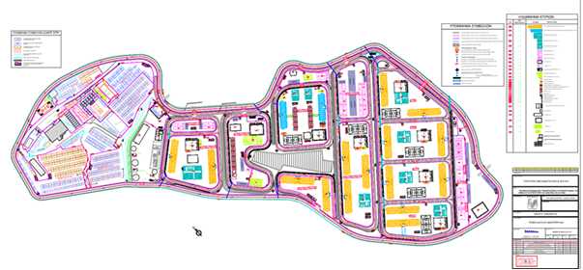
2. Wash reception conditions in Lesvos RIC; toilets
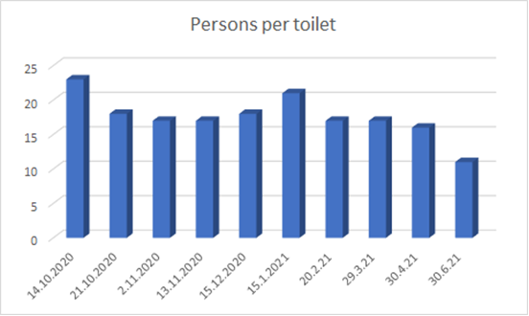
23 | 18,4 | 17,4 | 17,3 | 17,9 | 21 | 17,1 | 17,3 | 15,8 | 11,3
3. Wash reception conditions in Lesvos RIC; showers
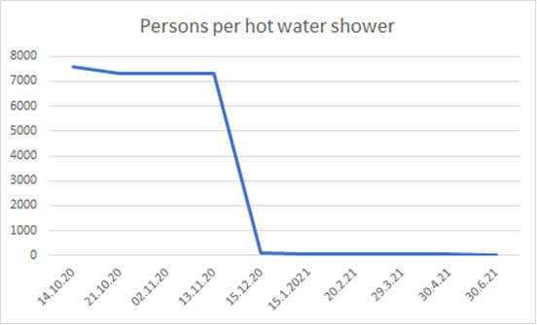
7600 | 7300 | 7300 | 7300 | 102 | 47 | 36 | 41 | 37 | 27
Asylum process
1. Greek Asylum Service: backlog
ASYLUM SERVICE: PENDING AND DECISION MAKING
Month | Pending decisions 1st Instance | Pending decisions 2nd Instance | Total of pending decisions | Percent Variance (%) | Decisions 1st Instance | Decisions2nd Instance
Dec-19 | 123.515 | 15.635 | 139.150
Jan-20 | 126.181 | 14.376 | 140.557 | 1,0% | 3.783 | 1.862
Feb-20 | 126.083 | 12.334 | 138.417 | -1,5% | 5.273 | 3.619
Mar-20 | 120.165 | 11.599 | 131.764 | -4,8% | 6.904 | 1.443
Apr-20 | 105.501 | 9.061 | 114.562 | -13,1% | 15.853 | 2.541
May-20 | 99.936 | 8.485 | 108.421 | -5,4% | 6.026 | 1.926
Jun-20 | 94.829 | 7.900 | 102.729 | -5,2% | 8.715 | 2.018
Jul-20 | 91.383 | 7.637 | 99.020 | -3,6% | 7.071 | 1.935
Aug-20 | 88.286 | 7.664 | 95.950 | -3,1% | 5.551 | 1.517
Sep-20 | 84.212 | 6.373 | 90.585 | -5,6% | 7.045 | 2.552
Oct-20 | 82.646 | 5.182 | 87.828 | -3,0% | 4.198 | 2.247
Nov-20 | 79.353 | 3.851 | 83.204 | -5,3% | 5.835 | 2.179
Dec-20 | 76.335 | 3.553 | 79.888 | -4,0% | 4.798 | 1.174

2. Greek Asylum Service: decisions
1st INSTANCE DECISIONS
 | YtD 2019 | Monthly  Percent Variance (%) | YtD 2020 | Monthly  Percent Variance (%) | Percent Variance 2019-2020 %
January | 3.807 |  | 3.783 |  | -1%
February | 8.393 | 120% | 9.056 | 139% | 8%
March | 13.184 | 57% | 15.960 | 76% | 21%
April | 18.033 | 37% | 31.813 | 99% | 76%
May | 21.730 | 21% | 37.839 | 19% | 74%
June | 24.701 | 14% | 46.554 | 23% | 88%
July | 28.646 | 16% | 53.625 | 15% | 87%
August | 31.924 | 11% | 59.176 | 10% | 85%
September | 36.306 | 14% | 66.221 | 12% | 82%
October | 40.844 | 12% | 70.419 | 6% | 72%
November | 45.303 | 11% | 76.254 | 8% | 68%
December | 49.974 | 10% | 81.052 | 6% | 62%
3. Greek Asylum Service: type of decisions
Type of Decision | Number# | Percentage%
Refugee Status | 26.371 | 33%
Subsidiary Protection | 7.954 | 10%
Rejection(on the substance) | 22.821 | 28%
Rejection (as unfounded) | 9.484 | 12%
Act of termination of the process | 4.340 | 5%
Withdrawal of the asylum application | 1.148 | 1%
Case archived | 8.934 | 11%
Total | 81.052 | 100%

* Reproduced as received, in the language of submission only.

